Zain Siddiqui

Link to the diagram: <https://app.diagrams.net/#G12RpqOlFNbojJmW0mIkYnQXeuThcvrRIy>

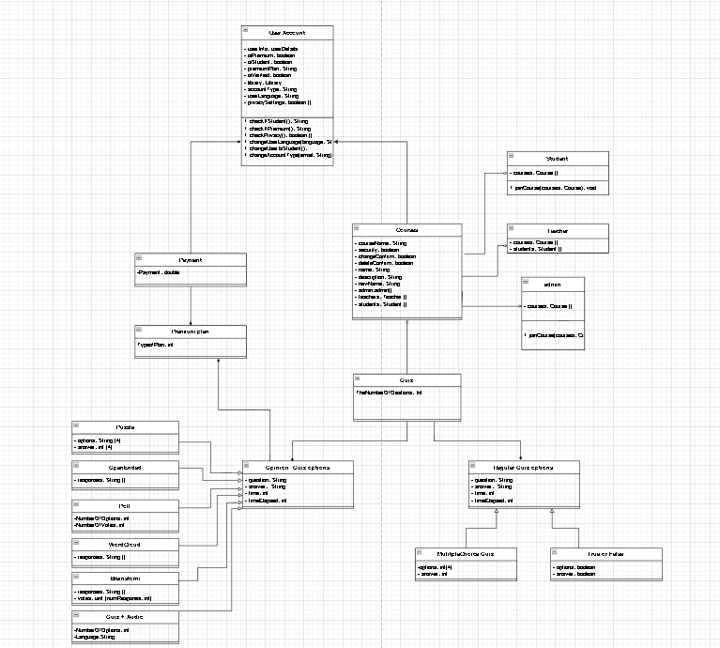

<https://www.youtube.com/watch?v=4IR3359fWE0>

1. Design a 10th type of question.

I would create a poll question where the user has two options yes or no with two different objects.

* 1. Describe how it works and why it might be useful. (2)

This could work in situations where the user needs to give an answer in True or False or Yes or no questions.

* 1. What attributes would it have? (2)

The poll question will have two attributes one will be the True and the other will be false.

* 1. What is its relationship to the other classes? (2)

This is a generalization relationship and superclass and subclass relationship with the Opinion Quiz option class. Where the Opinion Quiz option class is the superclass and this poll is the subclass.

* 1. Include a diagram of the class. (2)

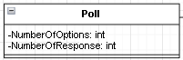

1. You are tasked to redesign Kahoot to be used in a setting outside of the school of your choice. How might the classes change to tailor specifically for that application? Consider changes of relationships/attributes/methods. (2)

This will change everything dramatically because in school we use certain quiz types that may be useful, but if we were to go into a different setting outside of school we may not need half of the quizzes that are listed in kahoot, therefore less methods, less attributes. The relationship could also change. The exact opposite could also happen where more thighs could be added like more features that are not needed in a school environment, that may be more useful in a business company. Therefore changing the relationship between the classes, changing the methods, attributes.